# S1 Submission: Mark Elbre – 2396048

## Feature Mock-up: Tournament Viewing Page

Each tournament would have; its own page for viewing its details and information; offering the means to sign-up to it for registered users who are in a team for the game the tournament is about; and viewing the tournament’s live status (who is playing who, what past scores have been, etc).

The below page:

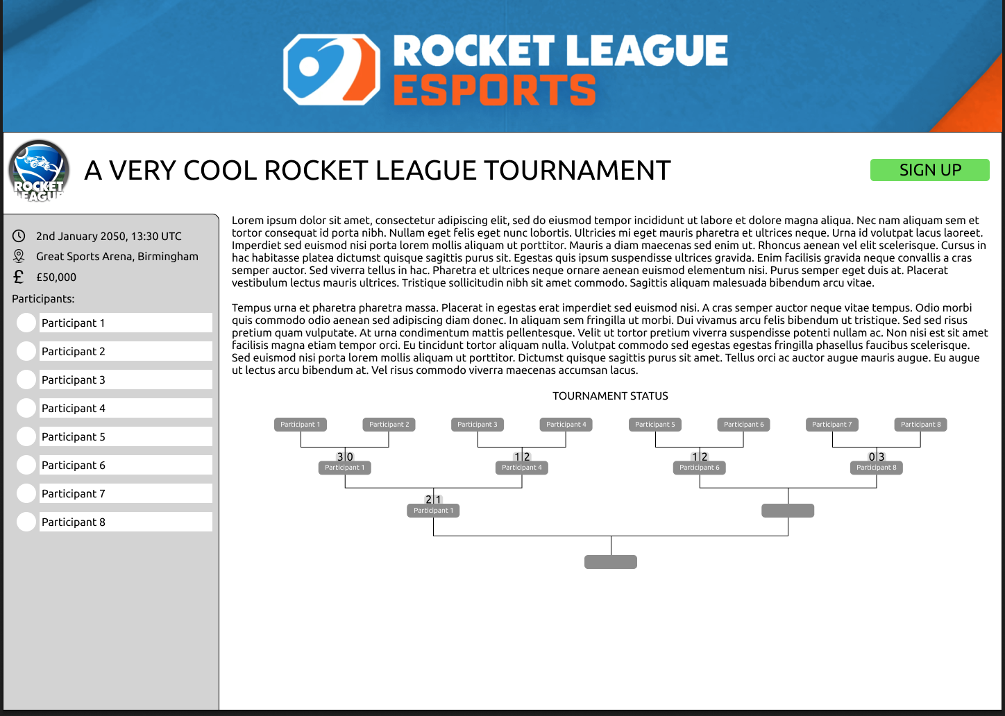

*Submitted externally as a PNG too, for zooming.*

Contains all the necessary details for someone to use to sign up to it. The page is fictionally in the context of a Rocket League tournament to better show what it might look like.

As prerequisites, users must already be in a team for that game, in order to sign up, and only the **Team Leader** would be able to be the one to sign up.

This means that once a team leader has found a tournament they’d like to participate in, signing up is **quite literally 1 click**, aligning with the user persona of a team leader, below…

## User Persona: Team Leader

## 

*Submitted externally as a PDF/PNG too, for zooming.*

## Git Commit and SSH Setup:

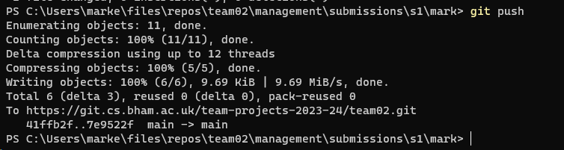

Above is a screenshot showing I can push to team 2’s GitLab repository.

## Time Sheet

